**Practical – 1**

**AIM:String Validation**

**Code:**

#include <stdio.h>

#include <string.h>

#include <stdbool.h>

bool isValidString(const char *str){

int length=strlen(str);

if(length<2 || length>7 || str[length - 1]!='b' ||str[length -2]!='b' ){

return false;

}

for(int i=0;i<length-2;i++){

if(str[i]!='a'){

return false;

}

}

return true;

}

int main() {

char input[7];

printf("Enter a string: ");

scanf("%d", input);

if (isValidString(input)) {

printf("string is valid for a*bb.\n");

} else {

printf("string is not valid for a*bb.\n");

}

return 0; }

**Output:**

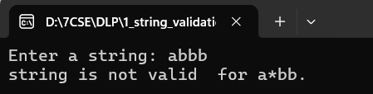\

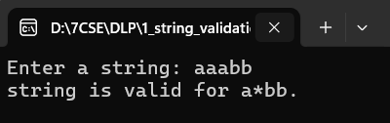

**Code:**

#include <stdio.h>

#include <string.h>

int getNextState(int currentState, char input) {

case 1:

if (input == 'a') return 2;

if (input == 'b') return 3;

break;

case 2:

if (input == 'a') return 1;

if (input == 'b') return 4;

break;

case 3:

if (input == 'a') return 4;

if (input == 'b') return 1;

break;

case 4:

if (input == 'a') return 3;

if (input == 'b') return 2;

break;

}

return -1;

}

int main() {

char testString[] = "abbabab";

int currentState = 1;

int i;

for (i = 0; i < strlen(testString); i++) {

char input = testString[i];

currentState = getNextState(currentState, input);

if (currentState == -1) {

printf("Rejected: Invalid transition encountered.\n");

return 0;

}

}

int acceptingStates[] = {1};

int numAcceptingStates = sizeof(acceptingStates) / sizeof(acceptingStates[0]);

int isAccepted = 0;

for (i = 0; i < numAcceptingStates; i++) {

if (currentState == acceptingStates[i]) {

isAccepted = 1;

break;

}

}

if (isAccepted) {

printf("Accepted: The test string abbabab is accepted by the finite automata.\n");

} else {

printf("Rejected: The test string abbabab is not accepted by the finite automata.\n");

}

return 0;

}

**Output:**

